## MATLAB SETUP TO WORK WITH CASPROS

**àFor Matlab files: Use CASPR_private shared by Gino**

CASPR Directory structure

**àImportant file locations**

ROSInterfaceàCASPR_MYO_ROSInterface/CASPR_private/src/HardwareInterface/CableRobotActuator/MYO-muscle/ MyoInterface.m

SimulationàCASPR_private_scripts\members\Dominic\OperationalSpaceControl

HardwareàCASPR_private_scripts\members\Dominic\Myo-Hardware

*Actual implementation of the controllers are inside the following classes*

**àClasses**

CASPR_private\master\src\Analysis\Control\OperationalSpaceControl\ReactiveQPControl

CASPR_private_scripts\members\Dominic\OperationalSpaceControl\IterativeLearningControl

**àFile modification for making the CASPR work CASPROS**

Following modifications are made in the CASPR_private library

1. CASPR_MYO_ROSInterface/CASPR_private/scripts/local/CASPR_private_scripts/members/Dominic/Useful Scripts/CreateSphericalTraj.m à Create the spherical trajecoty.
2. In script_BMArm_.... make the following changes
   1. Comment
      1. % CASPR_configuration.SetGlobalModelMode(ModelModeType.COMPILED);
      2. % CASPR_configuration.SetReuseCompiled(1);
   2. Change
      1. cdpr = model_config.getModel('WORKING', model_config.defaultOperationalSetId);

to

cdpr = model_config.getModel('WORKING', model_config.defaultOperationalSetId,ModelModeType.COMPILED);

* + 1. traj_filename = sprintf('%s/scripts/local/%s.otraj', CASPR_configuration.LoadHomePath(), trajectory_id);

to

traj_filename = sprintf('%s/%s.otraj', CASPR_configuration.LoadHomePath(), trajectory_id);

**[1]**

## IMPORTANT GIT DIFFERENCE

The modifications from the last part are also shown by ‘git diff <commit_previous> <commit_present> <file_path>’

|  |
| --- |
| **11/06/2020: Git ‘difference’ showing the changes made by Dominic for running the BMARm** |
| script_BMArm_ILC_MyoExperiment.m |
|  |
|  |
|  |
| script_BMArm_MyoExperiment.m |
|  |
|  |
|  |

|  |
| --- |
| **26/06/2020: Git ‘difference’showing the changes made by Dominic for running the BMARm** |
| script_BMArm_MyoExperiment.m |
|  |
| script_BMArm_ILC_MyoExperiment.m |
|  |
| MyoExperiment.m |
|  |

## HOW TO RUN CASPROS WITH FPGA:

**Preparation**

1. Connect the Ethernet cable
2. Check the ethernet cable connection with arp -a:

1. Start ‘roscore’ on the desktop of Linux computer.
2. Perform ROS Ethernet configuration setup on the PC:
3. Modify .bashrc on Linux PC:
4. Change the ROS_IP to 10.42.0.1
5. The IP can be different according to the ifconfig:

(might need to source the .bashrc file for activating the changes)

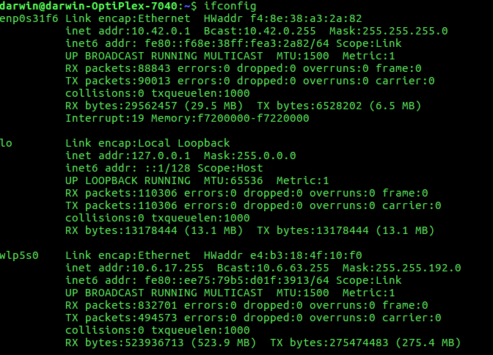

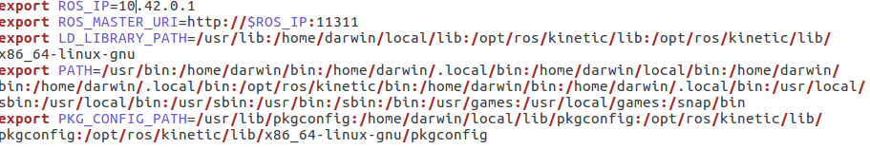

1. ‘ssh’ to nano board because linux is also running on it.

|  |
| --- |
| ssh root@10.42.0.111 |
| Password: Roboy2016 |

1. Perform ROS Ethernet configuration setup on the nano:
2. Modify .bashrc on FPGA board:

|  |
| --- |
| vim .bashrc |

(might need to source the .bashrc file for activating the changes)

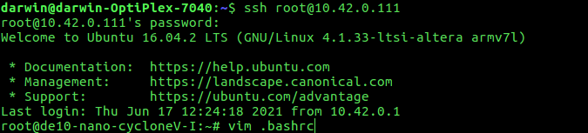

1. Modify the ROS_IP accordingly (The same method as modifying the ip in Linux PC):

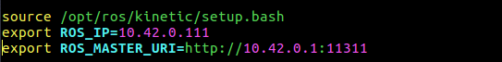

ROS_IP should be the IP address of the DE nano board.

**Hardware Steps**

1. Connect the Ethernet cable
2. Check the ethernet cable connection with arp -a:

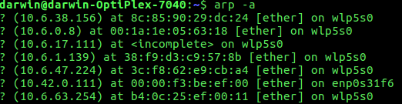

1. Connect to the FPGA board with the ip address in arp -a (Terminal 1):

|  |
| --- |
| ssh root@rosrun casper |
| Password: Roboy2016 |

1. Open a new ternimal (Terminal 2) on Linux PC and do:

|  |
| --- |
| roscore |

1. Start the roboy_plexus in the DE nano terminal (Terminal 1, ssh one) before powering on the robot motors

|  |
| --- |
| ./roboy_plexus |

1. Power on the motors
2. Open another terminal window (Terminal 3), source the catkin package.

|  |
| --- |
| source ~/caspros/devel/setup.bash |

1. Turn on the myo_manager (Terminal 3 ) to get access to the FPGA board:

|  |
| --- |
| roslaunch myo_manager launch_BMArm_with_FPGA.launch |



1. Open another terminal window (Terminal 4), source the catkin package.

|  |
| --- |
| source ~/caspros/devel/setup.bash |

1. Run (Terminal 4 ) the low-tension node to tighten the BMArm

|  |
| --- |
| rosrun caspr_cpp low_tension |



Running matlab script (not done):

All the devices should be connected to a switch, and we need to check the ip addresses and modify all the three .bashrc

Open another terminal window, source the catkin package.

source ~/caspros/devel/setup.bash

We will be running the matlab interface node:

rosrun caspr_cpp matlab_to_myomuscles



**Precautions:**

|  |
| --- |
| 1. Cut the switch (red circular) if its on and then supply power. |
|  |
| Note: Noise form the power supply fan is normal |
|  |
| 1. Twist the switch counter clockwise and the power lights (first light) on motor will turn on green. |
|  |
| 1. rosrun caspr_cpp low_tension |
|  |
| 1. stop myo_manger, roboy_plexus, other terminals running then power the motors off. |
|  |
| 1. If required cables can be dragged out, if its really tight then the cables are stuck in the motor pulleys. |
|  |

Change the cables

Cables are long enough but not too long enough

## HOW TO CONNECT A LINUX PC AND WINDOWS PC THROUGH ETHERNET CABLE FOR ROS

Connection between Linux PC and Any Windows Laptop:

1. Connect both of the computer with ethernet cables to a switch.
2. Do ifconfig on Linux and ipconfig on windows, and find the IP address for both of them. They should be like 10.42.0.1 on Linux and 10.42.0.X on windows.
3. Try to ping the Linux PC on windows machine with:

|  |
| --- |
| ping 10.42.0.1 |

If not succeed, check the IP address of the Linux machine and the ethernet connection.

1. Try to ping the window machine on the Linux PC with:

|  |
| --- |
| ping 10.42.0.X (which is the IP address of the windows machine) |

If not working, we need to change some settings of the windows firewall as following:

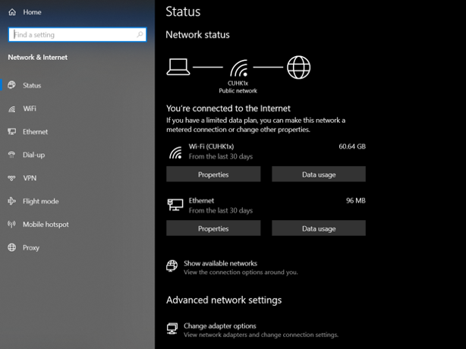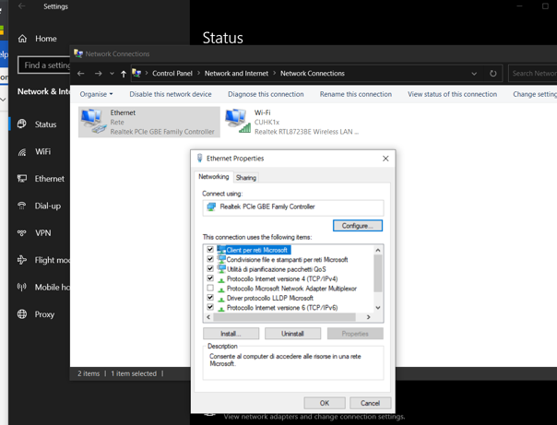

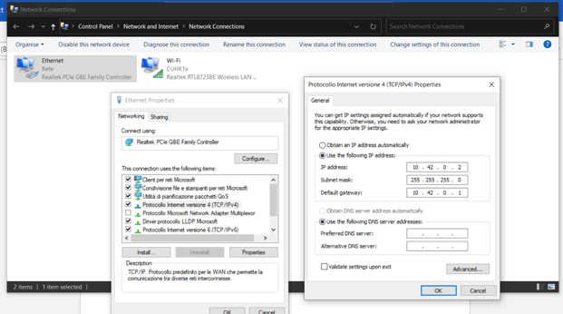```````````````````

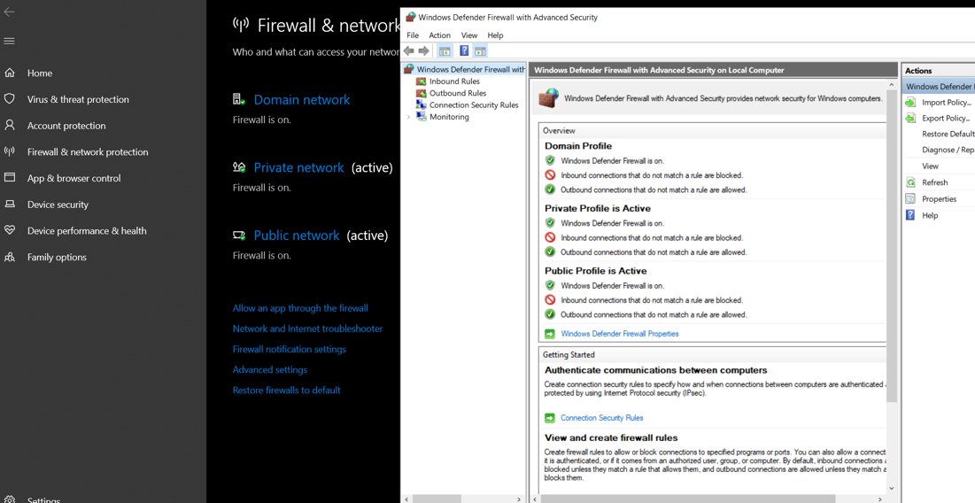

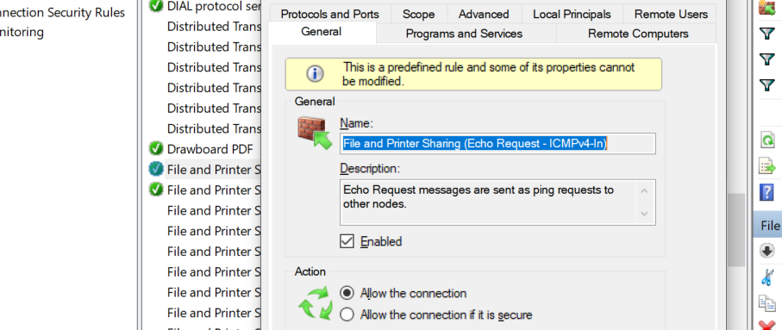

## HOW TO CONNECT WINDOWS MATLAB PC AND ROS RUNNING ON LINUX PC

1. Run roscore
2. Ssh to the FPGA and ./roboy_plexus
3. Roslaunch myo_manager
4. Rosrun myo_muscle (Follow the steps described in ‘Hardware Steps’)
5. Run matlab on windows

Caution: Ros not initialized

Check the ROS_MASTER_URI 10.42.0.1 (The ROS_MASTER_URI should be same as that of the Linux PC, where ROS master is running)

Type rosinit in the matlab command line window to check if the ROS toolbox is installed

*Can not create subscriber, check the rostopic list on the Linux PC, and rerun the steps above to make sure /MATLAB/FeedBack is on the list*

Rostopic reference:

Only roscore:



Add plexus:

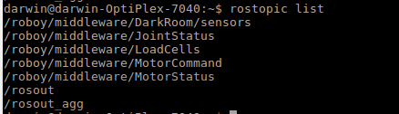

Add myo_manager:

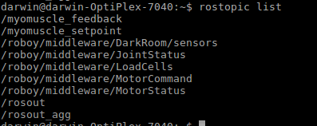

Add rosrun caspr_cpp matlab_to_myomuscle: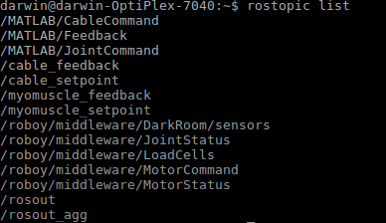

## IMPORTANT NODE-TOPIC DIAGRAMS FROM RQT

./roboy_plexus

./roboy_plexus

roslaunch myo_manager launch_BMArm_with_FPGA.launch

rosrun capr_cpp matlab_



## QUESTIONS ASKED DURING MEETING WITH DOMINIC

26/06/2020

* Important packages/nodes
  + *low_tension* :Tighten the cables
  + *rest*: hold length commands and position
  + *matlab_to_myomuscles*
  + *position_control_xml* :Test the BMArm’s joint angles by running the arm in vertical, horizontal, twisting and flexing motions. IT sends commands from *CASPR_ROS*.
* Why the FK of cables to joints is in the *CASPR_ROS?*
  + Due to time constraint Dominic could not implement it in the MATLAB.
* MyoExperiment 146, what is the usage of *f_feedback?*
  + To check whether the BMArm is actuated by the positive force in the reactive controller
  + ILC
* What’s the input and output interface of BMArm (FPGA Board ./roboy_plexus)?
  + Roboy plexus is to control the myomuscle and let it go to the certain position.
* How to set the initial position of the cables?
  + *low_tension* initial position to rest
  + *rest*: hold length command and position
* How to do the cable length calibration, test the FK?
  + Not much information or idea.
* Check the understanding of the flow chart
  + The flow chart drawn on Inkscape is correct
* Why the second part of FK (joint to task) is inside the controller?
* The second simulation experiment with unexpected traj is not match
  + Could not fix it
* ILC error function
* The choice of *alpha and beta*
* The stability

## IMPORTANT CONCLUSIONS REACHED

* Since Darwin has already implemented the *ControllerSImulator* class in CASPR, thus, Dominic separated the simulations and hardware. He executed simulations directly with Darwin CASPR framework and implemented the hardware class, *MyoExperiment* class separately.
* By increasing time span between the joint space trajectory points, the OL controller performed well. We have also reduced the time step from 0.01 s to 0.033 s.

1. |  |
   | --- |
   | * Chen: He is not an author and even he don’t knows about the MATLAB implementation thoroughly. |
   | **Author: 1st Dominic aka Yin Pok Chan (Masters), 2nd author is another master student who left. |

  